Simulating ChatGPT Locally
Building a Simple Simulation
The aim here is to create a basic function that emulates a chatbot's response mechanism using conditional statements.
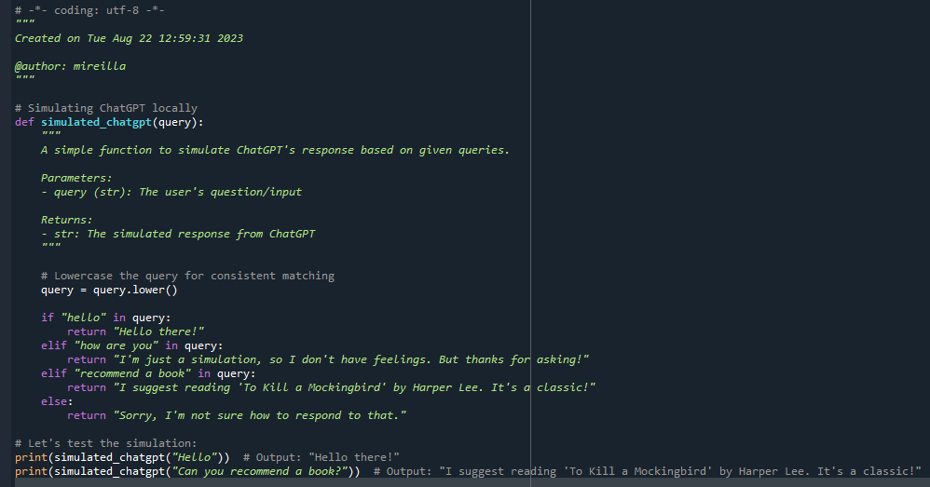

Exercise 1: Problem: Expand the simulated_chatgpt function to handle questions about the weather, e.g., "How's the weather today?". It should return a random weather condition from a list, like ["sunny", "cloudy", "rainy"].
Exercise 2: Problem: Enhance the simulated_chatgpt function so that when asked, "Tell me a joke", it responds with a random joke from a predefined list of jokes.

